EVENT MANAGEMENT SYSTEM
“ Momento ”

Submitted By :

Mihir Vaidya ( 202504104610024 )
Vivek Gosai ( 202504104610023 )
Chirag Modi ( 202504104610142 )
Viraj Patel ( 202504104610086 )

Guided By:
Ms. Shivani Talaviya

For partial fulfilment of the requirements
For the Degree of Master of Computer Application,
Shrimad Rajchandra Institute of Management and Computer Application
Uka Tarsadia University
Feb , 2026

DECLARATION
We hereby declare that the project titled Event Management System is fully implemented by us. It is neither paid nor copied. Even though, later on, in case of any infringement found for this project work, we are solely responsible for the same and understand that as per UGC norms, the University can revoke the degree conferred to us.

Enrollment No | Students Name | Signature
202504104610024 | Mihir Vaidya
202504104610023 | Vivek Gosai
202504104610142 | Chirag Modi
202504104610086 | Viraj Patel

As a guide, I assure you that there is no plagiarism found in the submitted document.
Guide Name: Ms. Shivani Talaviya
Signature:
Date: Place: SRIMCA ,UTU

Acknowledgement

It is my privilege to express my sincere gratitude to the individuals who helped me, directly or indirectly, in conducting this project work. I would like to thank Uka Tarsadia University for including this project work activity in the M.C.A. curriculum.

I am deeply grateful to our Director, Dr. Dharmendra Bhatti, and my project guide, Ms. Shivani Talaviya for providing the valuable guidance and suggestions necessary for the successful completion of this project. I am also indebted to all the respondents, whose cooperation made this project possible.

Finally, I extend my special thanks to every faculty member of the Shrimad Rajchandra Institute of Management and Computer Application (SRIMCA), as well as my friends and family, for their constant support throughout this endeavour.

INDEX

Chapter 1 : Introduction of System……………………………………………..…………………….1
  - Problem Statement ………………………………………………………………………..6
  - Solution for Problem Statement ……………………………………………………...7
  - Proposed Solution ………………………………………………………………………….7
  - Objectives of the System …………………………………………………………………7
  - System Scope ……………………………………………………………………………......8
  - System Limitations ………………………………………………………………………...8
  - Tools and Technologies Used ………………………………………………………….9
Chapter 2 : System Analysis …………………………………………….……………………………….10
2.1 Functional Requirements ………………………………………………………………10
2.2 Data Model Description …………………………………………………………………11
Chapter 3 : Conceptual Diagram ………………………………………………………………………14
3.1 Use Case Diagram ………………………………………………………………………………14
3.1.1 User …………………………………………………………………………………………..14
3.1.2 Admin ……………………………………………………………………………………….15
3.2 Activity Diagram ……………………………………………………………………………….16
3.2.1 Activity Diagram for Login / Registration …………………………………..16
3.2.2 Activity Diagram of Browsing Package ………………………………………..17
3.3.3 Activity Diagram of Booking Package …………………………………………18
Chapter 4 : System Design…..……………………………………………………………………………..19
4.1 Database Design ………………………………………………………………………………19
4.1.1 Event Collection …………………………………………………………………….......19
4.2.2 Package Collection ……………………………………………………………………..21
4.3.3 User Collection ………………………………………………………………………….23
4.2 API Screenshots ……………………………………………………………………………….28
4.2.1 Event API ………………………………………………………………………………….28
4.2.2 Package API ………………………………………………………………………………29
4.3 User Interface Design ………………………………………………………………………30
4.3.1 Home Page ………………………………………………………………………………...30
4.3.2 Recent Events …………………………………………………………………………….31
4.3.3 Package Display ………………………………………………………………………….32
4.3.4 Package Detail …………………………………………………………………………….33
4.3.5 About Us ……………………………………………………………………………………..34
4.3.6 Contact Us …………………………………………………………………………………..35
4.3.7 Login …………………………………………………………………………………………..36
4.3.8 Registration ………………………………………………………………………………..36

Chapter 1 : Introduction Of System

1.1 Problem Statement
Event planning and management is a complex process that requires coordination of various services such as venue booking, catering, decoration, and scheduling. Traditional event management methods rely on manual processes, phone calls, and physical booking systems, which are time-consuming, inefficient, and prone to errors.

There is a need for an automated system that allows users to explore event packages, view details, and book events easily from a single platform. The system should also manage user registration, event packages, and booking information efficiently.

The proposed Event Management System (Momento) provides a digital platform that simplifies event planning by offering event packages, booking functionality, and centralized management.

The proposed solution is a web-based Event Management System that provides:
- Online event browsing
- Event package selection
- User registration and login
- Package details viewing
- Event booking functionality
- Centralized database management

1.2 Solution for Problem Statement
The proposed solution is a web-based Event Management System that provides:
- Online event browsing
- Event package selection
- User registration and login
- Package details viewing
- Event booking functionality
- Centralized database management
- Make a custom Event
The system reduces manual work and provides a simple and efficient way to manage events.

1.3 Proposed Solution
The proposed system is a web-based platform that provides:
- Online event package browsing
- User authentication and registration
- Package details with images and catering information
- Event booking functionality
- Centralized data storage
- Secure backend services
The system reduces manual work and improves efficiency by digitizing the event management process.

1.4 Objectives of the System
The main objectives of the Event Management System are:
- To provide an online event booking platform
- To simplify event package selection
- To manage user accounts securely
- To maintain centralized database of events and users
- To provide easy access to event information
- To reduce manual workload in event planning
- To improve user experience using modern UI design

1.5 System Scope
The scope of the system includes:
- User registration and login
- Viewing event packages
- Viewing package details
- Event booking functionality
- Data storage in MongoDB database
- Backend API integration
- Authentication
- Verify Register User

Future Scope :
- Online payment integration
- Admin dashboard
- Email notifications
- Event scheduling management

1.6 System Limitations :
- No payment gateway integration
- No advanced admin panel
- Limited booking management
- No event cancellation feature
- No notification system
- No multi-user role management
1.7 Tools and Technologies Used
Frontend Technologies :
- React.js — Component-based UI development
- HTML5 — Page structure
- CSS3 — Styling and layout
- JavaScript — Dynamic functionality
Backend Technologies :
- Node.js — Server runtime environment
- Express.js — REST API framework
Database :
- MongoDB — NoSQL document-based database
- Mongoose — MongoDB object modeling
Development Tools :
- Visual Studio Code
- Thunder Client API testing
- GitHub version control

CHAPTER 2 — SYSTEM REQUIREMENTS
2.1 Functional Requirements
User Management
- User registration
- User login authentication
- Password encryption
- Session handling
Event Management
- View event packages
- View package details
- Display package images
- Display catering services
Booking Management
- Book selected event
- Store booking details
- Associate booking with user
Database Management
- Store user records
- Store Event Packages
- Retrieve Data dynamically

2.2 Data Model Description
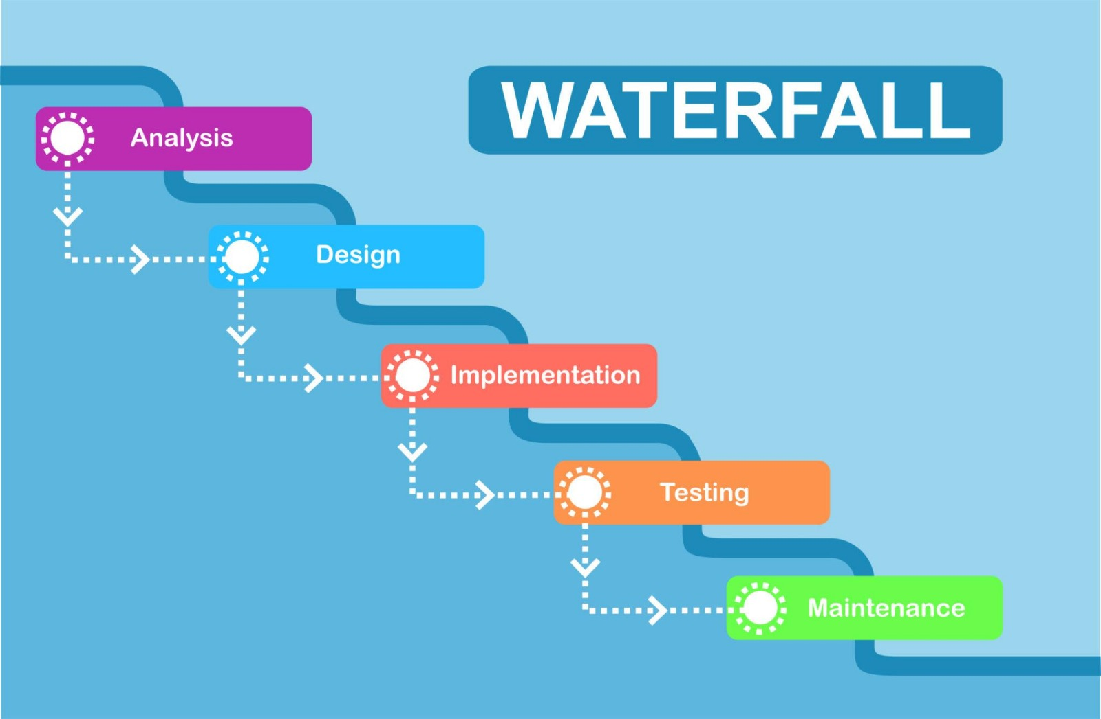
The Waterfall Model is a linear and sequential software development process where each phase must be completed before moving to the next. This model is suitable for the Event Management System because the project requirements, system design, and expected functionalities were clearly defined before implementation.
The Waterfall Model is a linear and sequential software development process where each phase must be completed before moving to the next. This model is suitable for the Event Management System because the project requirements, system design, and expected functionalities were clearly defined before implementation.

Phases of Waterfall Model Applied in the Project
1. Requirement Analysis
In this phase, the requirements of the Event Management System were identified. The system needed to allow users to register, log in, view event packages, and book events. The administrator required functionality to manage events, packages, and users.
2. System Design
During the design phase, the overall structure of the system was planned. UML diagrams such as Use Case Diagrams, Activity Diagrams, and Data Models were created to represent the system architecture and interaction between components. The database structure was also designed using MongoDB collections.
3. Implementation
In this phase, the actual development of the system took place. The project was implemented using the MERN stack (MongoDB, Express.js, React.js, Node.js). Frontend interfaces were developed using React, while backend APIs were implemented using Node.js and Express.js to handle authentication, package management, and booking operations.
4. Testing
After implementation, the system was tested to ensure all functionalities worked correctly. Testing included checking user authentication, booking validation, package display, and database operations to verify that the system behaved as expected.
5. Deployment and Maintenance
In the final phase, the application was executed and demonstrated as a complete working system. Any minor errors discovered during testing were corrected to improve system performance and reliability.

Conclusion
The Waterfall Model was selected for the Event Management System because it provides a structured development approach with clearly defined phases. Since the project requirements were well understood from the beginning and the scope remained stable throughout development, the Waterfall model helped in organizing the development process and maintaining proper documentation for the project

CHAPTER 3 — CONSEPTUAL DESIGN
3.1 Use Case Diagram
Actors :
3.1.1 User
3.1.2 Admin

3.1.1 User

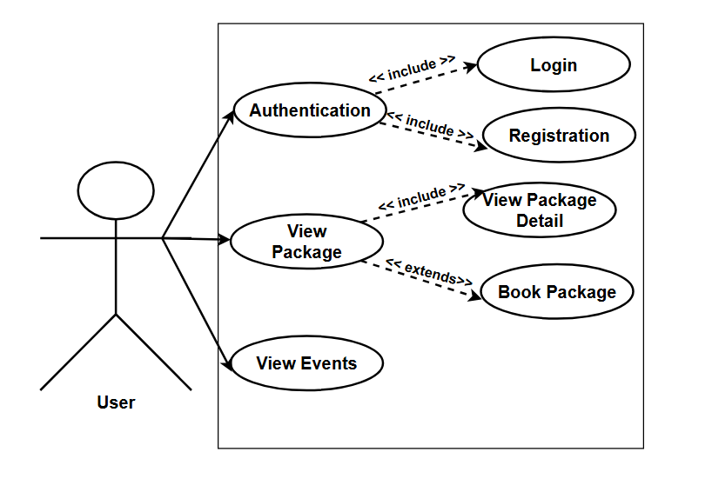

- User can Login but first he have to register through Registration Page
- User can View Packages .
- User also view Event that are recently organized by Momentoe.

3.1.2 Admin :
<<include>> : Use <<include>> when a use case always performs another use case as part of its process.
<<extends>> : Use <<include>> when a use case always performs another use case as part of its process.

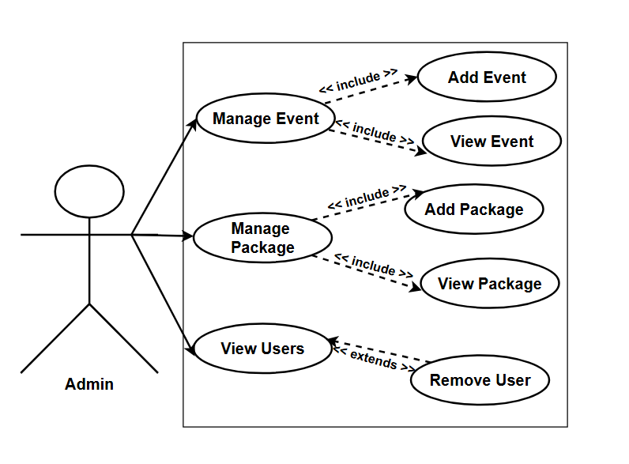
- Admin View Packages
- Admin View Events
- Admin View User
- Admin manage Events
- Admin manage Packages

3.2 Activity Diagram :
3.2.1 Activity Diagram for Login / Registration :

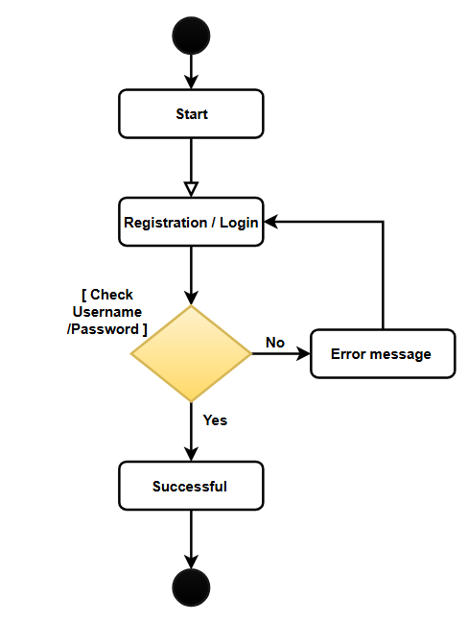

3.2.2 Activity Diagram of Browsing Package :

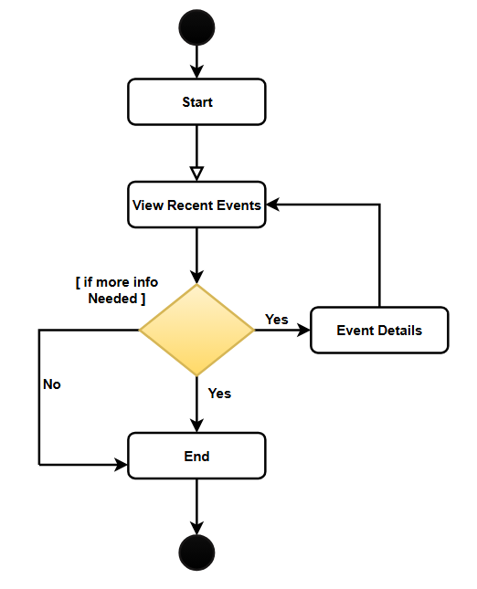

3.3.3 Activity Diagram of Booking Package :

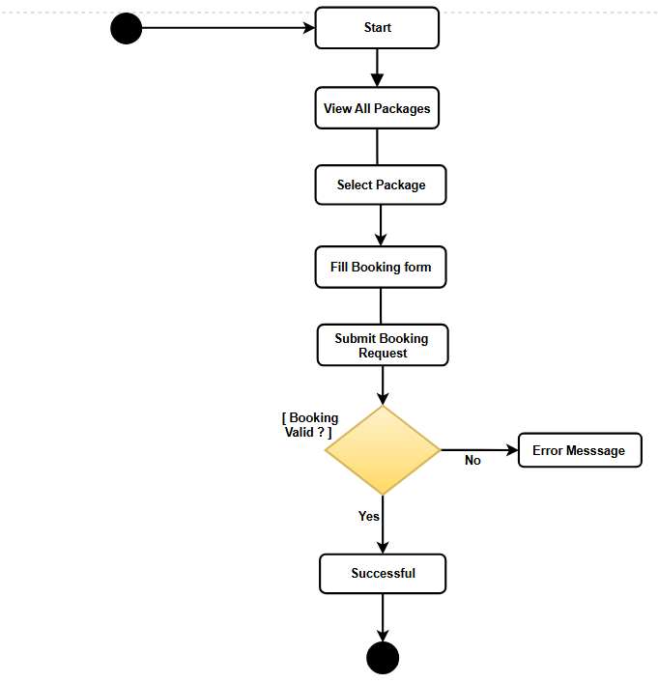

CHAPTER 4 — SYSTEM DESIGN
4.1 Database Design :
4.1.1 Event Collection
Field | Field Type | Constraints | Description
id | ObjectId | Primary Key, Auto-generated | Unique identifier for each event document.
title | String | Required, Not Null | Stores the name or title of the event.
description | String | Required | Provides details about the event.
date | Date | Required | Stores the date on which the event will take place.
location | String | Required | Stores the venue or location of the event.
image | String | Optional | Stores the image file name or URL related to the event.
createdAt | Date | Default: Current Date | Records the date and time when the event was created.
updatedAt | Date | Auto Updated | Records the date and time when the event details were last updated.

MongoDB Design Approach
- Document-based storage
- Flexible schema

Event Collection :
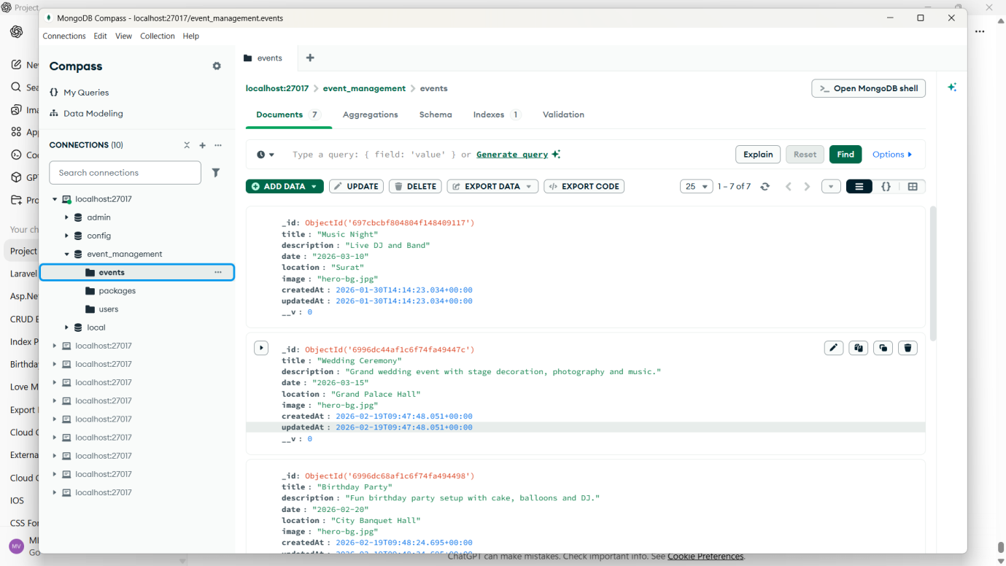

4.2.2 Package Collection :

Field | Fild type | Constreint | Description
id | ObjectId | Primary Key, Auto-generated | Unique identifier for each package document.
name | String | Required, Not Null | Stores the name of the event package.
description | String | Required | Provides details about the services included in the package.
price | Number (Integer) | Required, Minimum Value | Stores the cost of the event package.
startDate | Date | Required | Indicates the starting date of the package availability.
endDate | Date | Required | Indicates the ending date of the package availability.
images | Array | Optional | Stores image URLs or file paths related to the package.
catrering | Array | Optional | Stores catering items or food services included in the package.
createdAt | Date | Default: Current Date | Records the date and time when the package was created.
updatedAt | Date | Auto Updated | Records the date and time when the package details were last updated.

Package Collection :

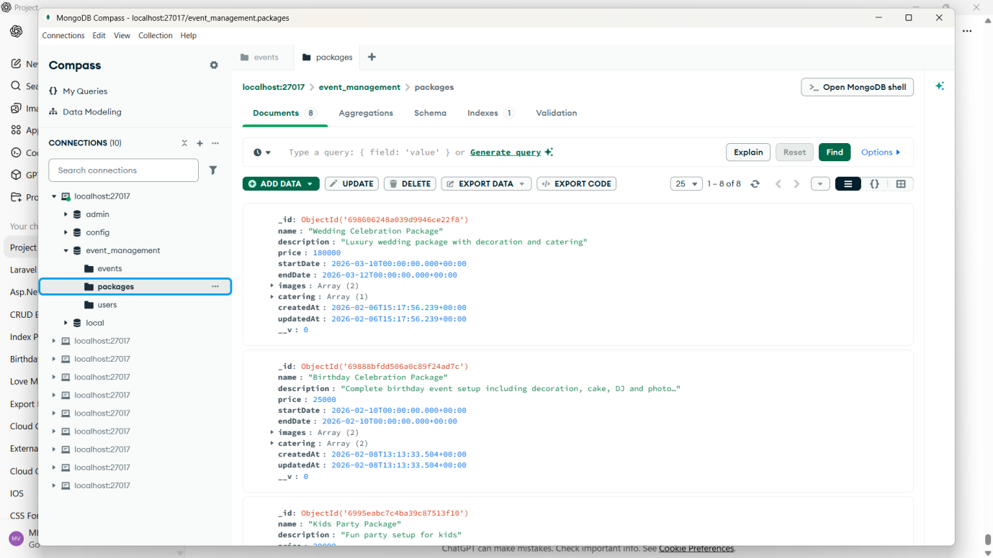

4.3.3 User Collection :
Field | Field type | Constraint | Description
Id | ObjectId | Primary Key, Auto-generated, Required | Unique identifier for each user document.
fullname | String | Required, Not Nul | Stores the full name of the user.
email | String | Required, Unique | Stores the user’s email address used for login and communication.
password | String | Required | Stores the encrypted/hashed password of the user.
phone | String | Required | Stores the user’s contact phone number.
createdAt | Date | Default: Current Date | Records the date and time when the user account was created.
updatedAt | Date | Auto Updated | Records the date and time when the user information was last updated.

User Collection :
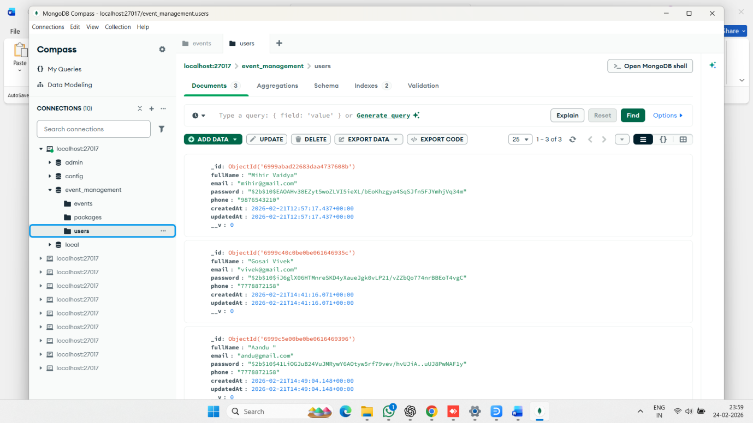
Event Document :

{
"_id": {
"$oid": "697cbcbf804804f148409117"
},
"title": "Music Night",
"description": "Live DJ and Band",
"date": "2026-03-10",
"location": "Surat",
"image": "hero-bg.jpg",
"createdAt": {
"$date": "2026-01-30T14:14:23.034Z"
},
"updatedAt": {
"$date": "2026-01-30T14:14:23.034Z"
},
"__v": 0
}

Package Collection Document :

{
"_id": {
"$oid": "698606248a039d9946ce22f8"
},
"name": "Wedding Celebration Package",
"description": "Luxury wedding package with decoration and catering",
"price": 180000,
"startDate": {
"$date": "2026-03-10T00:00:00.000Z"
},
"endDate": {
"$date": "2026-03-12T00:00:00.000Z"
},
"images": [
"hero-bg.jpg",
"hero-bg.jpg"
],
"catering": [
{
"thaliName": "Premium Wedding Thali",
"description": "Paneer, Dal Makhani, Butter Naan, Sweet",
"price": 1500,
"_id": {
"$oid": "698606248a039d9946ce22f9"
}
}
],
"createdAt": {
"$date": "2026-02-06T15:17:56.239Z"
},
"updatedAt": {
"$date": "2026-02-06T15:17:56.239Z"
},
"__v": 0
}

User Collection Document :

{
"_id": {
"$oid": "6999abad22683daa4737608b"
},
"fullName": "Mihir Vaidya",
"email": "mihir@gmail.com",
"password": "$2b$10$EAOAHv38EZyt5woZLVI5ieXL/bEoKhzgya4SqSJfn5FJYmhjVq34m",
"phone": "9876543210",
"createdAt": {
"$date": "2026-02-21T12:57:17.437Z"
},
"updatedAt": {
"$date": "2026-02-21T12:57:17.437Z"
},
"__v": 0
}

  - API Screenshots :

4.2.1 Events :
4.2.2 packages :
    - Events :

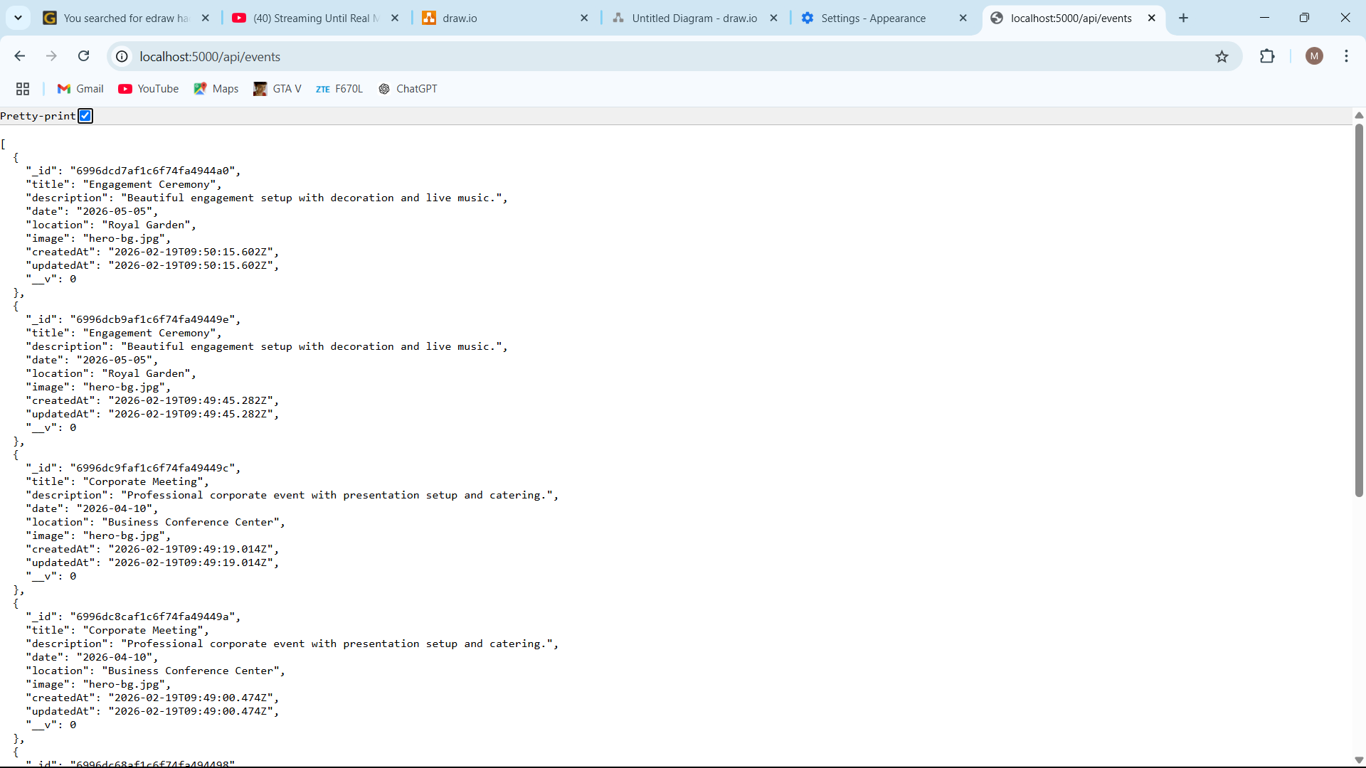
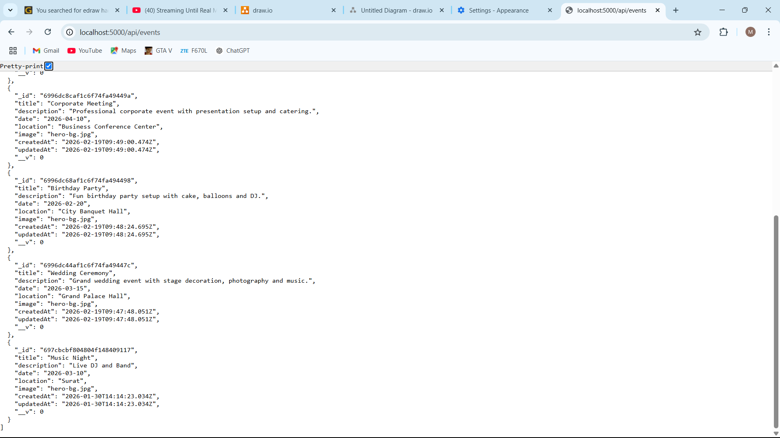
4.2.2 Packages :

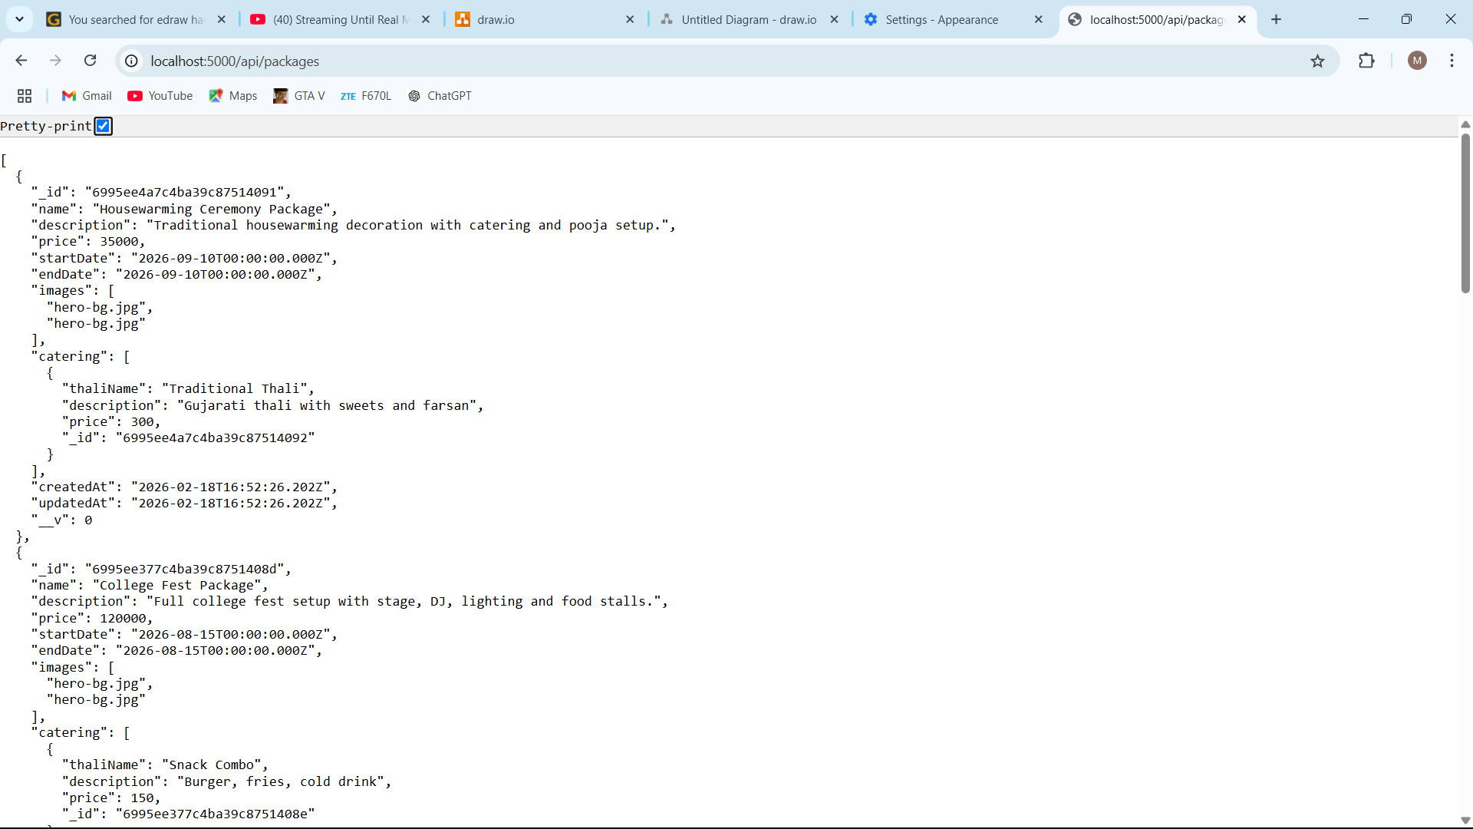

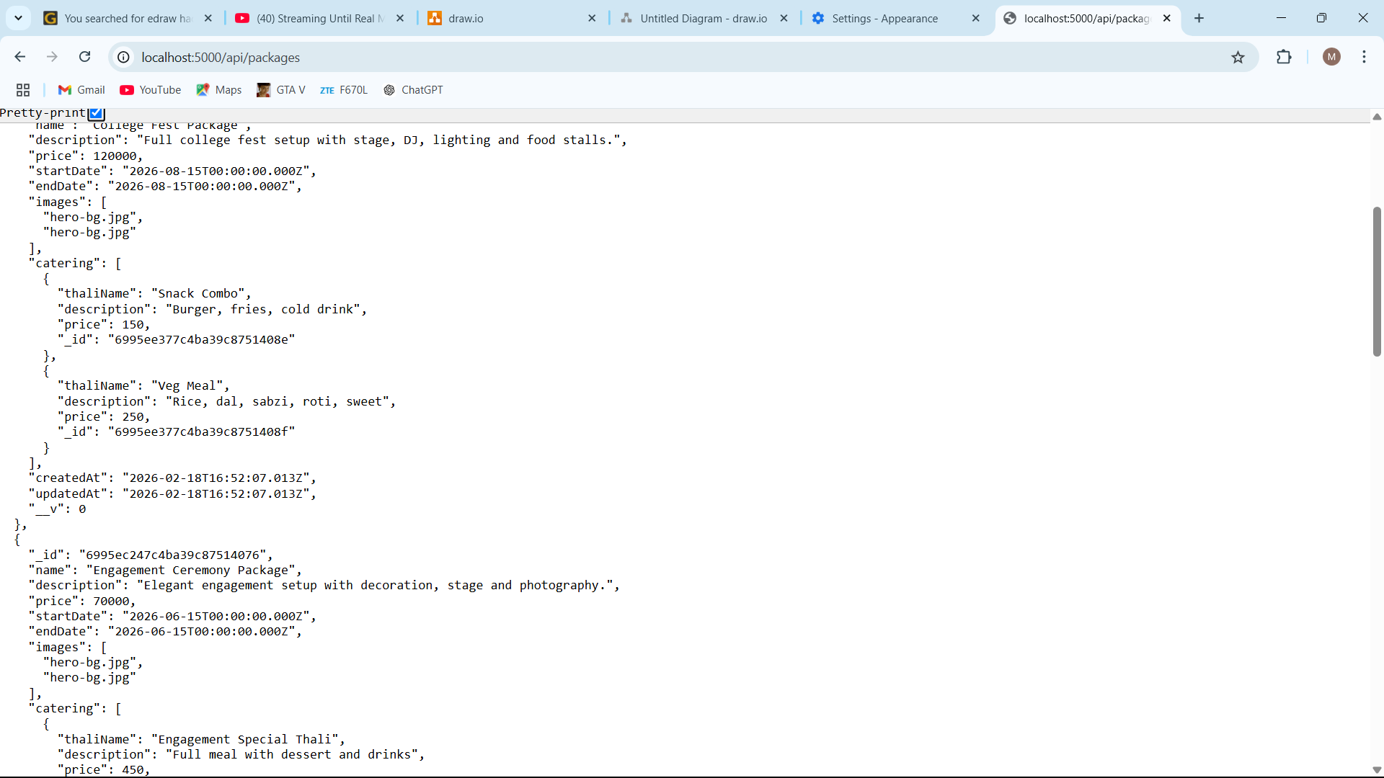

4.3 Frontend Design :
4.3.1 Home Page

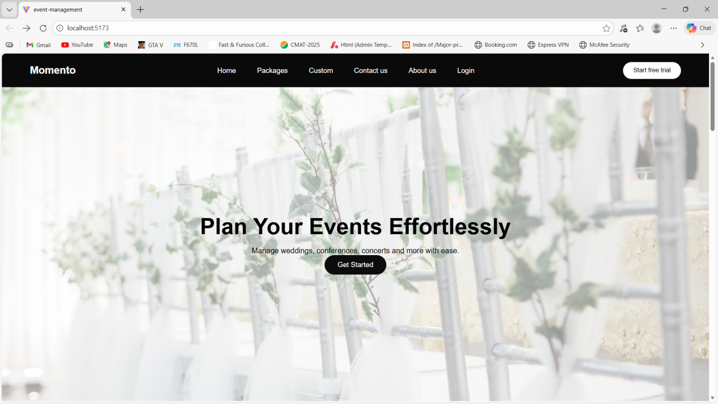

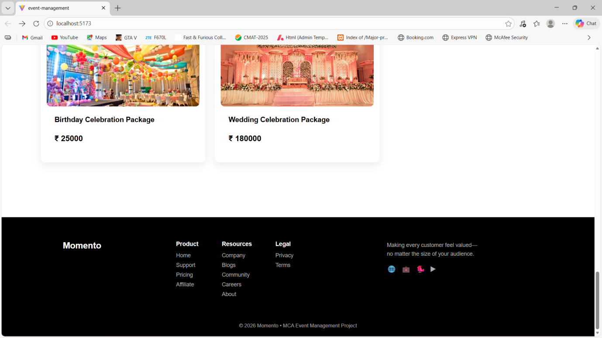

    - Recent Events :

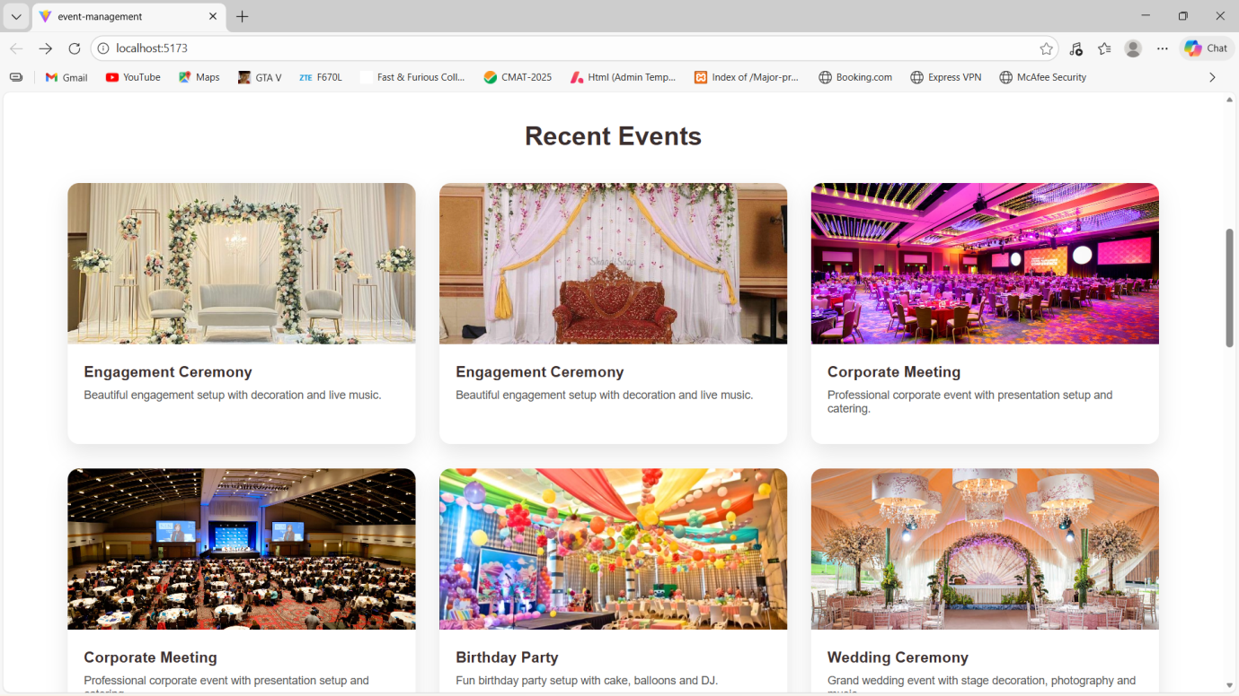

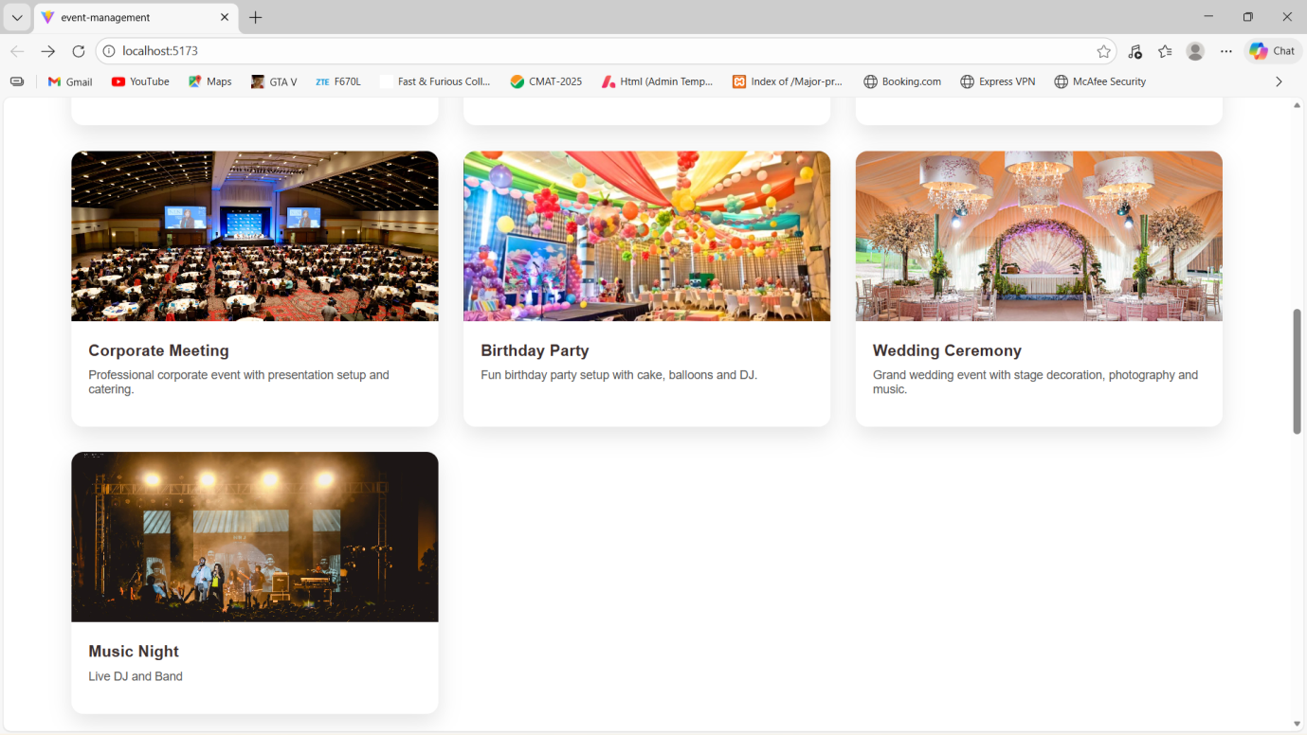

    - Package Display Page :

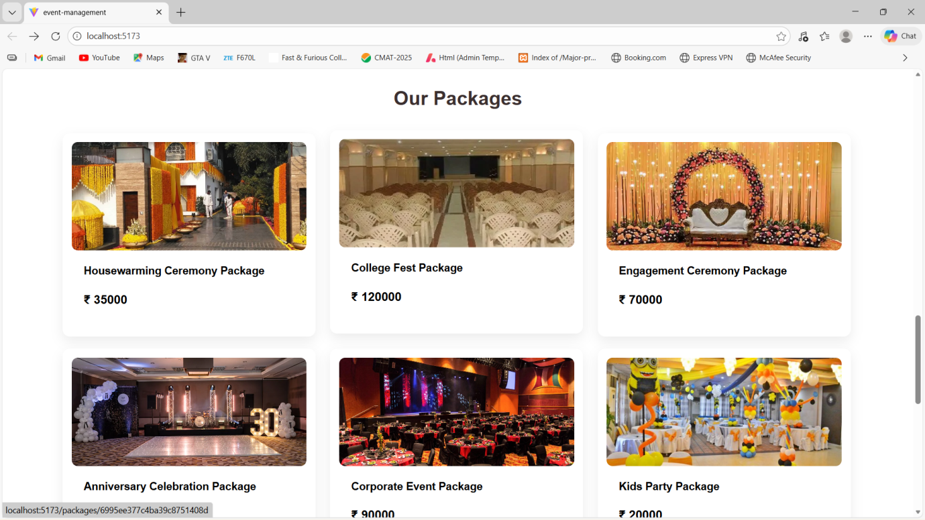

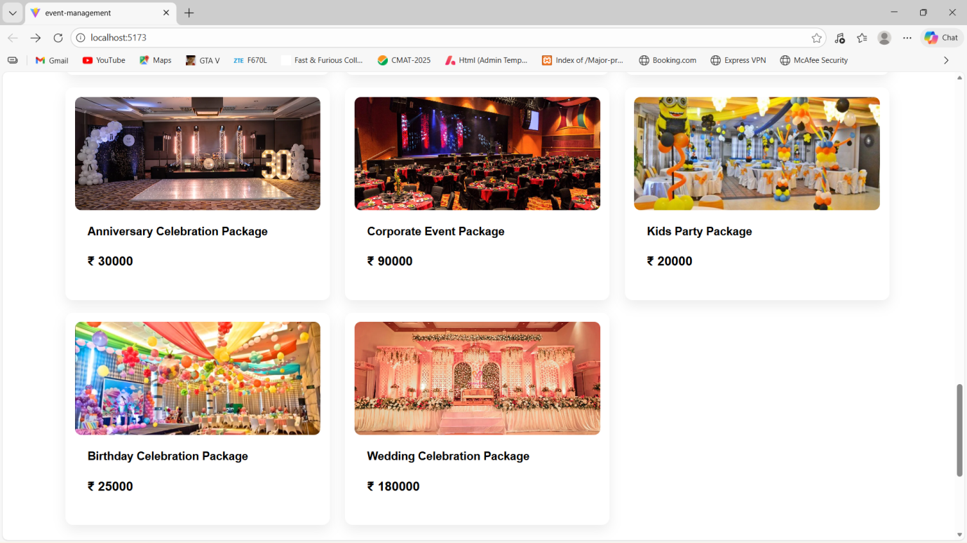

    - PackageDetail Page :

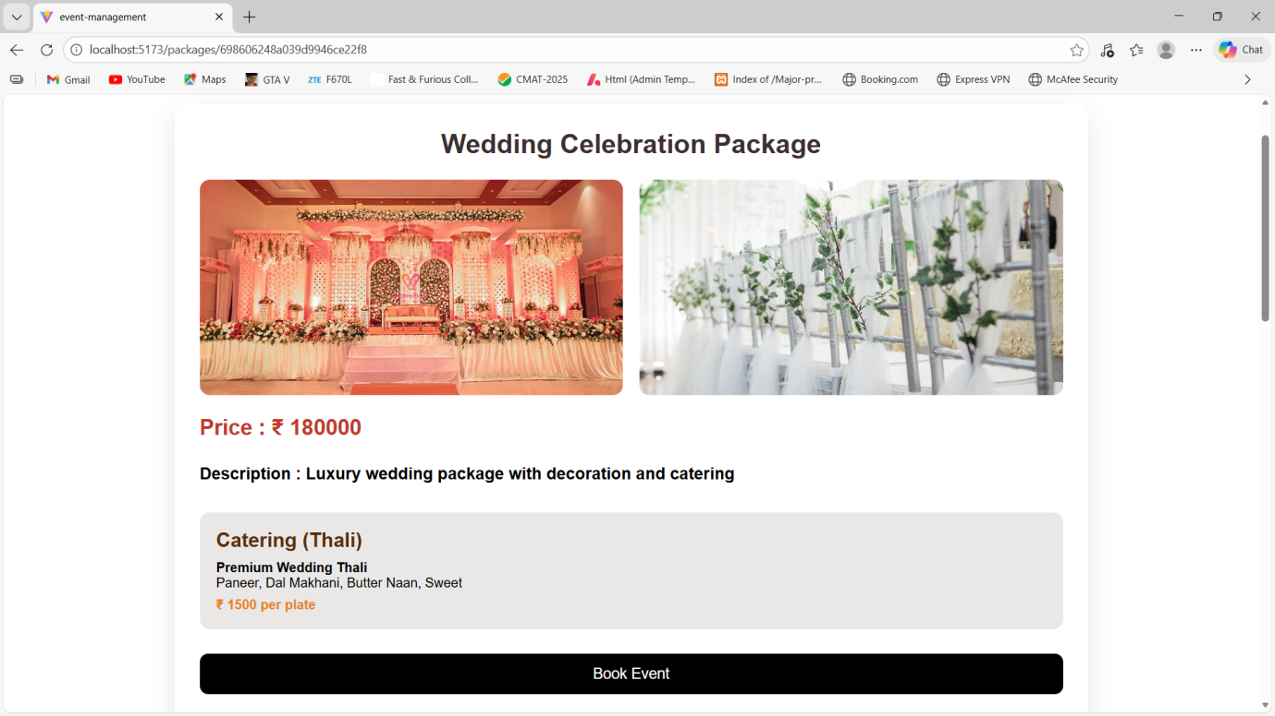

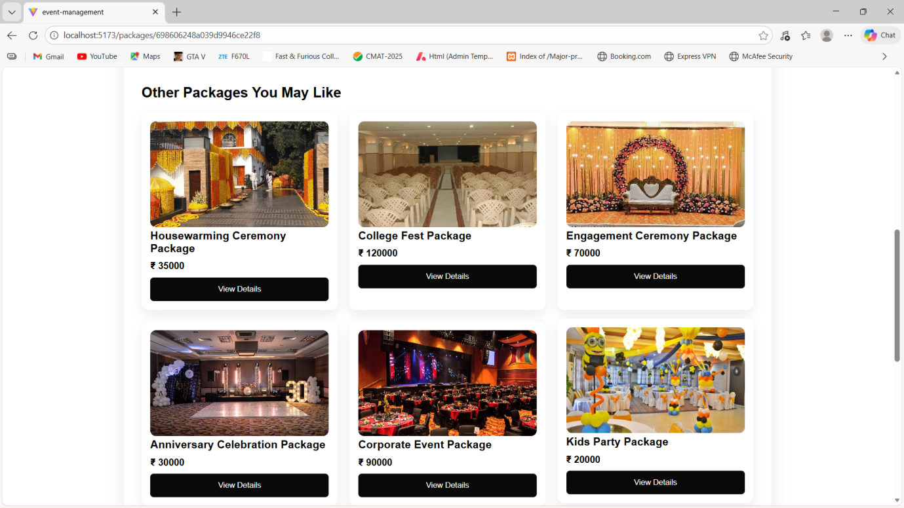

    - About Us Page :

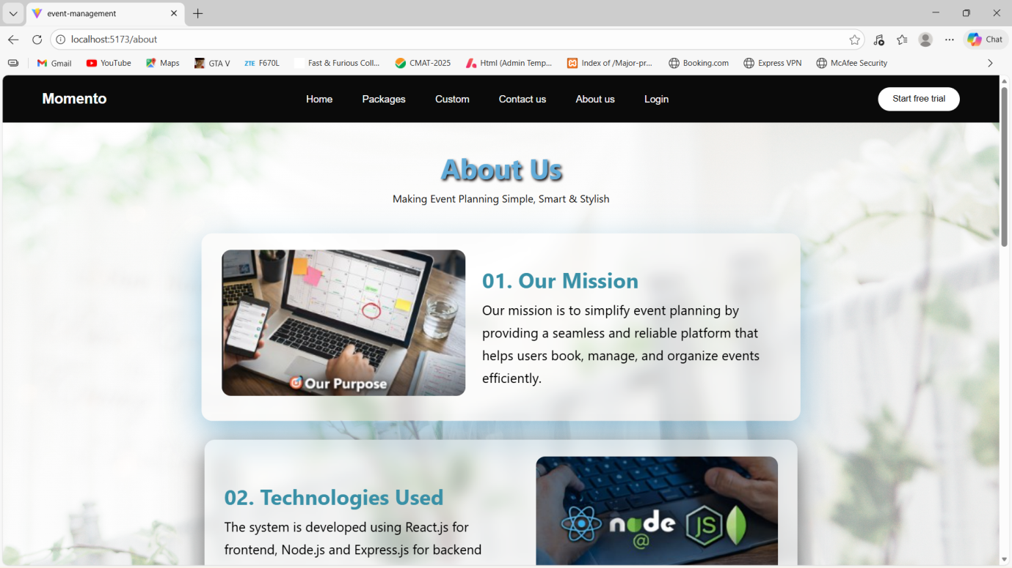

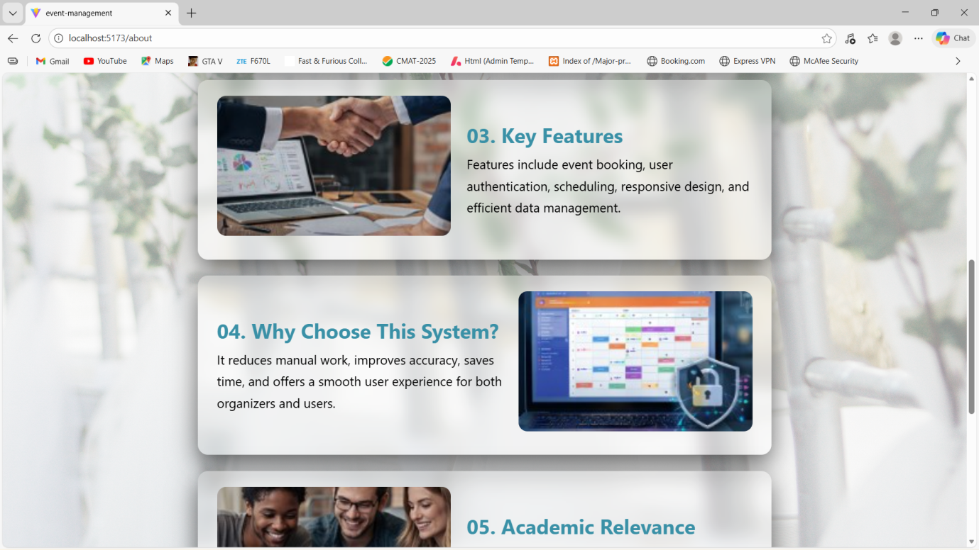

    - Contact Us Page :

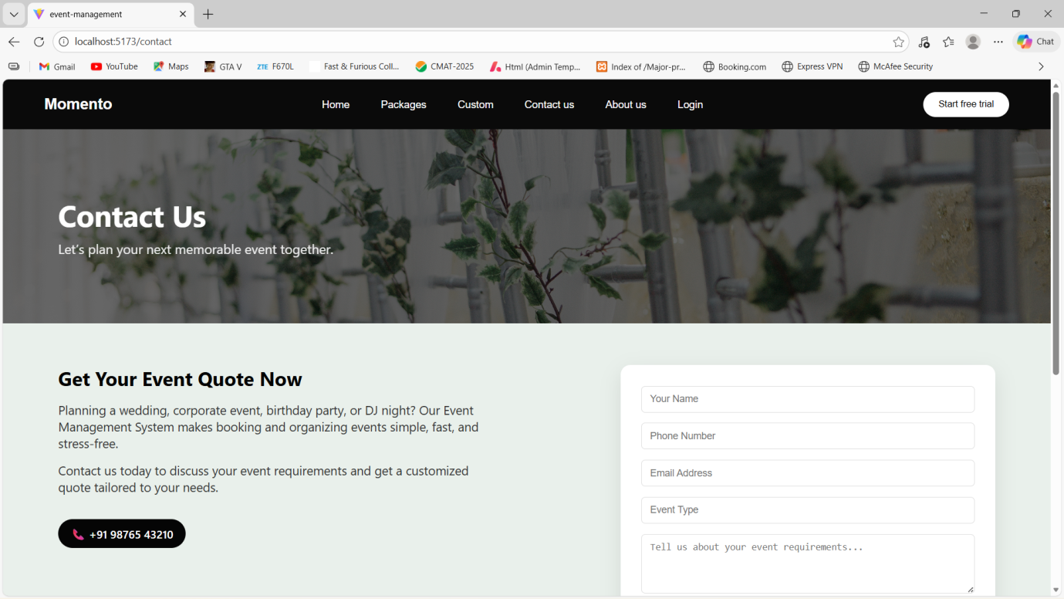

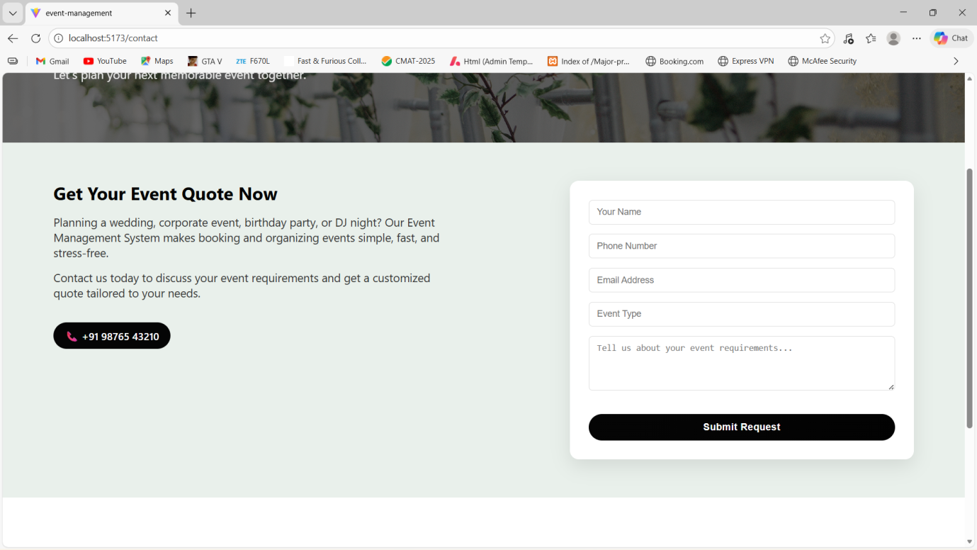

    - Login Page :

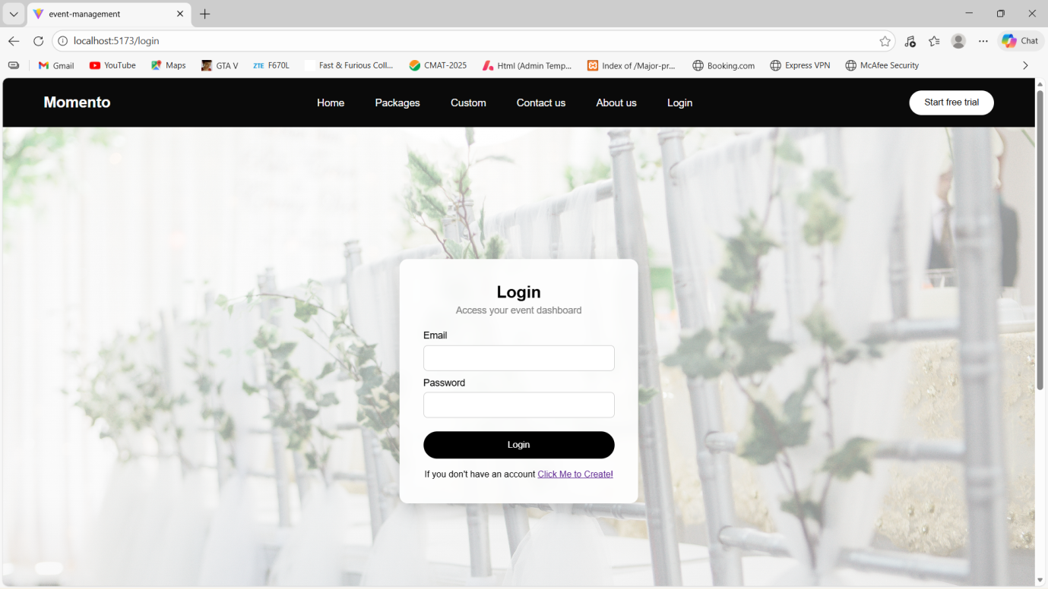

    - Register Page :

